|  |  |
| --- | --- |
| **Stage Discovered** | **Defect Count** |
| Requirements Review | 3 |
| Design Review | 4 |
| Code Review | 7 |
| Testing | 21 |
| Acceptance Testing | 0 |

The total size of the software is 185 FP.

Calculate the DRE and DD for the project and help the management analyze data.

**DRE**

The DRE of the software project is calculated as:

N1 = 3 + 4 + 7 + 20 = 35 defects

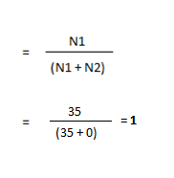N2 = 0

Therefore, the DRE

**DD**

DD is the defect density in a software project. This provides a normalized view of the software. The formula for DD is:

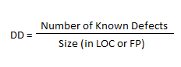



Therefore,

